SUBMISSION FOR BMJ INDUSTRY AWARDS 2022 MERCHANT ENVIRONMENTAL AWARD
Nomination: Bradfords Building Supplies

Bradfords has adapted to external risks and opportunities throughout its 252-year history. Embracing the challenge of reducing our impact on the environment continues our legacy of supporting the South-West community in which we serve.

Our environmental sustainability strategy has four pillars:
- Engagement and education
Building more sustainably represents challenges and change, and we knew we couldn’t expect our teams, customers, or communities to change overnight. Engagement and education initiatives include:

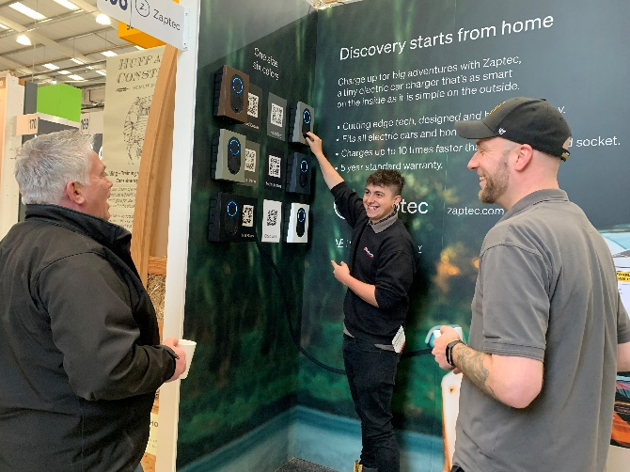
- In October 2021 we launched our Sustainability Champions scheme and have so far appointed 12 Sustainability Champions. These volunteers advocate our drive to reduce the company’s environmental impact, and the measures, products and methods which will help our customers and communities to build more sustainably. 2022 sees a dedicated programme of training for this group with support from suppliers.

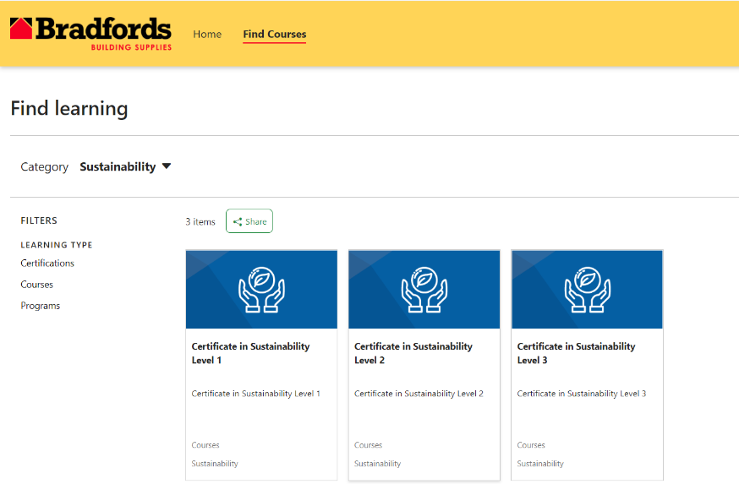
- Working with Cortexa, we initiated the development of an environmental sustainability syllabus for members of the BMF. We have now loaded this material into the online Bradfords Training Academy for the use of all our employees. This is further supported by material which Xtratherm made available to us along with in-house presentations that explain what we’re doing internally. In addition, in May we launch a comprehensive training programme available to staff which covers all the key aspects of a building including energy efficiency, net zero, heating and electricity, and water conservation.

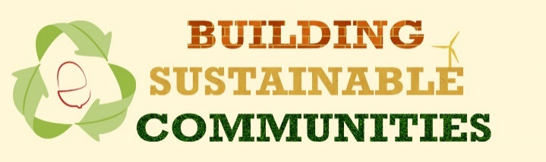
- In November 2021 we hosted our first ‘Building Sustainable Communities’ event in partnership with Trustmark. The event was designed to introduce a wider employee cadre as well as customers and the local community to the concept of building more sustainably. The event attracted over 250 physical attendees as well as 300+ online. Supported by 12 of our key suppliers, this event set the scene for 6-monthly events which aim to inform, inspire, and educate. This event will be repeated every 6 months.

- In parallel, we also launched our Bradfords Building Sustainable Communities website, providing customers and communities with access to relevant and useful information. We are continuing to develop this through 2022.

- Working with the Retrofit Academy, 5 of our team have undertaken their ‘understanding domestic retrofit’ level 2 course, and we have agreed to support their Devon-based pilot to increase engagement with the national retrofit strategy. In addition, we are putting one person per Somerset-based branch of Bradfords through a sponsored domestic retrofit course in partnership with the Somerset Retrofit Accelerator Project, who have also been hosting ‘retrofit trade mornings’ at local branches to raise awareness of the requirement and drive engagement with local trades.

- Products and services

- The category team at Bradfords continue to engage with suppliers to ensure that we are sourcing as with the environment in mind, focussing on not only operational benefits of products, but the associated embodied carbon. In addition, we challenge suppliers to support our teams with engagement at branch level to help teams understand how they are improving the environmental impact of their manufacturing/logistics, as well as the products themselves.

- Towards the back end of 2021 we further defined our renewables offering in partnership with local renewables business, RES.
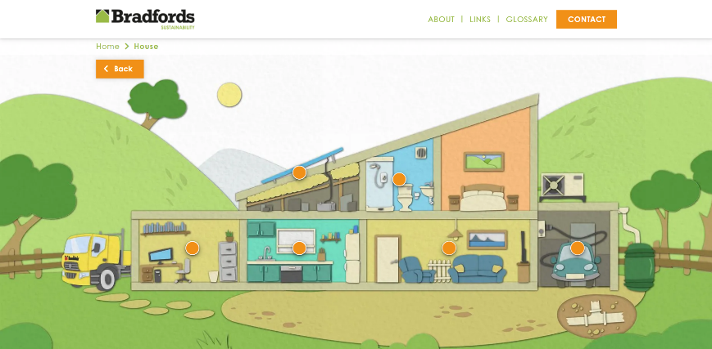
Further development of our customer facing sustainability proposition will be complete by May 2022, with comprehensive knowledge and advice content as well as links to products which support building for less environmental impact.

- Internal measures
2021 saw an increase of 7.4% in absolute GHG emissions, against a backdrop of a 30% increase in sales. Emissions per ticket reduced by 4.9%. The creation of our first in-depth carbon report gave insight into focus areas:
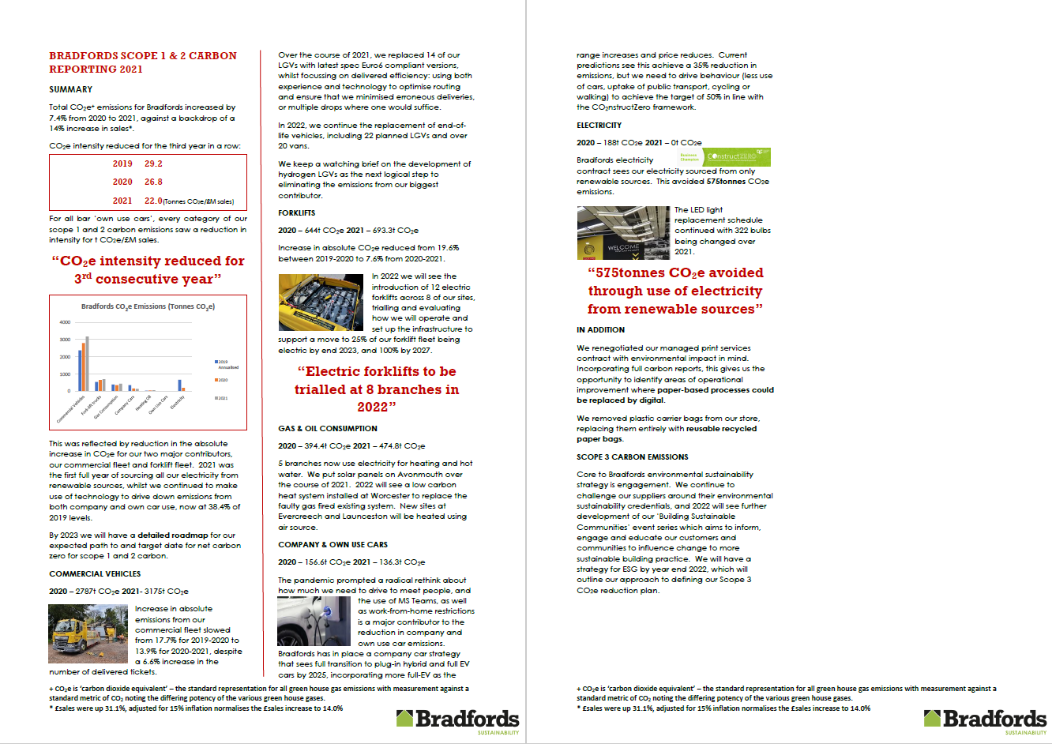

TRANSPORT. We are working with LGV suppliers to ensure that we will be approached about trials of alternatives to our current diesel fleet and expect to be an initial test case for electric cranes. We replaced 14 end-of-life LGVs with the latest Euro-6 variants in 2021. We are investigating HVO as an interim measure to reduce tailpipe emissions from our LGV fleet. We continue to use technology to optimise deliveries, having successfully incorporated BisTrack’s Journey Planner into the business.
Plans for an electric forklift fleet are well advanced, with the first 8 due in service in 2022, and total electrification by 2025.
Our company car policy has been adjusted in line with CO2nstructZero’s framework targets and replacements moving forward will be either plug-in-hybrid or full EV, which we are confident will meet the 50% emissions reduction by 2025, and complete elimination of emissions from the company car fleet by 2030.

ELECTRICITY. 2021 was our first full year of sourcing electricity from solely renewable sources, avoiding 575 tonnes of GHG emissions. We continue to apply ESOS2 throughout the business to achieve energy reduction, with the replacement of over 300 light bulbs to energy efficient LEDS. Solar panels were added to the roof of our Avonmouth branch in Q4 2021, our second branch to adopt this technology.

HEATING. We have various plans underway to replace end-of-life fossil fuel systems with low carbon alternatives at current and planned stores. At our Worcester branch, assessment of what to replace the now defunct fossil fuel system include building fabric optimisation, dynamic thermal modelling, and heat loss calculations. This assessment will provide the blueprint to inform how we retrofit further existing branches, and support the plans for net zero in planned future branches.
At our new Evercreech site we have plans for an air source heat pump, and have plans for electrically powered heat batteries at our new Launceston site.

PROCUREMENT. Numerous initiatives are underway:
Workwear: transition to fabrics made from recycled plastic
Printing: move to 100% recycled paper
In addition: Recycled content strapping; Paper bags for trade counter; Recycled pallet wrap for wrapping with safety dispenser PPT compliant; Paper tape for Taunton ecommerce new DC site; Plastic corner protectors are 100% recycled PPT compliant; Pallet strapping with recycled content PPT compliant; Corrugated boxes with recycled content; Pallet cover sheet – 100% recycled PPT compliant.
WASTE. We achieved 76% of non-recycled waste diverted from landfill in 2021, with a strategy in place for 2022 to make it easier for our branches to recycle specific waste streams – including the introduction of mill sized balers for plastic, avoiding disposing of rubble in general waste and trialling the recycling of bulk bags, alongside a waste management guide to support our teams.
- Representation
To ensure that decisions made in the sector or government which will affect us or our communities are made with the best information, Bradfords has taken on various representation roles. We chair the BMF Sustainability Forum, sit as the sole merchant on the government’s Green Construction Board, and were in 2021 one of the first 15 UK construction firms to sign up as a CLC CO2nstruct Zero business champion. We also signed up to support the Pallet Loop proposal which sees a step-change in the how pallets are recycled and reused in the construction industry.

This strategy is led by Giles Bradford, appointed as Head of Sustainability in 2021 to drive the business’ direction and influence our communities to support the environmental agenda. Giles also oversees the development of our ESG strategy and in 2022 will collaborate with other members of the H&B buying group to develop an ESG strategy that can be shared across the group’s membership. Once established, this strategy will give us the ability to test, set and hold ourselves accountable to targets for environmental sustainability, greenhouse gas emissions and waste.

